**CS 340 README Animal Shelter**

**Project Two: Animal Shelter**

*This application allows a user to access the Austin Animal Center database. The user will be able to filter the database using different search words and request specific information. This application features a dashboard with the Grazioso Salvare logo.*

**Motivation**

*This program was designed to teach users about working with databases and being able to manipulate the data within the database. Python works really well together with MongoDB.*

**Getting Started**

*To get this program started you would first,  
1. Enter MongoDB and import the csv file aac_shelter_outvome.csv.*

*2. Parse the data stored within the document*

*3. Authenticate a user would want to create both an Admin account and an aacuser account to access the database*

*4. Install python and run the program out of a notebook*

*5. Type in the address of the dash and connect*

**Installation**

*A current version of Python and Jupyter Notebook to run both the .py and the. ipynb files.*

*Access to the PyMongo to create functions in the dash.*

*MongoDB - to access the database.*

**Usage**

**Code Example**

Running Dash:  
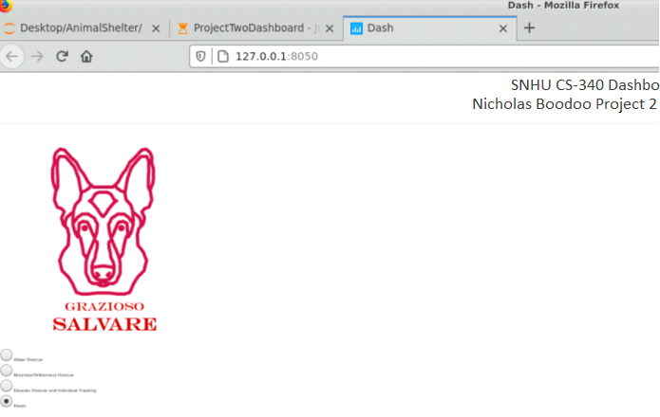

**Contact**

Nicholas Boodoo